**Pre Programme 1**

**Flyers**

**Pre-activity questionnaire**

**Patient flow chart**

**GP introductory letter template**

**Consent**

**Pre programme measures**

**Community Pain Management**

**Program**

**Programme 2**

**Session plans**

**Manuals**

**Support material**

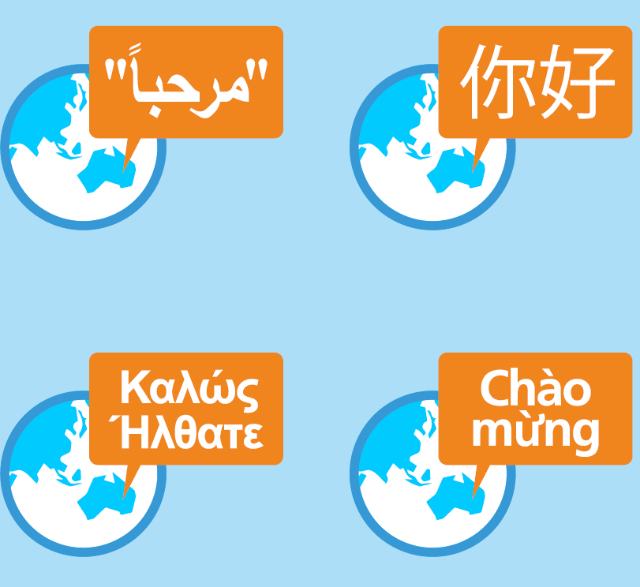

**Post-programme 3**

**Post programme measures**

**GP template feedback letter template**

**Participant feedback**

**Fidelity checklist**

**Participant certificate**

**Programme evaluation**

**Translations 4**

**Arabic**

**Greek**

**Vietnamese**

**Simplified Chinese**

**Traditional Chinese**

Tool Box

Index



Published Oct 2017. ACI/D23/886 © State of NSW (Agency for Clinical Innovation)