**RNSH ICU Covid-19 Intubation Guideline**

**Background**

Intubation and airway management may be aerosol generating procedures and there is a risk of transmission of pathogens.

This guideline should be followed for all patients with respiratory failure in the ICU who have tested positive for Covid-19 or who are awaiting test results.

This guideline outlines the approach to tracheal intubation by laryngoscopy. Awake fibre-optic intubation (AFOI) should be avoided if possible due to the high risk of aerosol generation and the transmission of Covid-19. The decision to perform AFOI should be made by a senior anaesthetist.

High flow nasal oxygen (HFNO) has been shown to be effective in Covid-19 patients and may decrease the number of patients requiring tracheal intubation. HFNO does not cause significant aerosolisation if the nasal cannulae are the right size for the patient and well secured.3 4

**1.0 On admission to ICU**

* Medical staff to perform airway assessment
* Bedside nurse to perform sizing of facemask and Guedel airway and place in a kidney dish in the patient’s room, in their packets.
* Nursing staff to prepare silver trolley with intubation tray (see below) for any patient requiring high flow oxygen (via facemask or high-flow nasal cannulae) and keep trolley outside room.

**2.0 Preparation for intubation**

**2.1 Personnel**

* The most senior operator should perform intubation to minimise risk to the team and because Covid-19 patients can desaturate very rapidly
* If difficulty is anticipated, an anaesthetist should be present (Fellow or above)
* At night, if a patient requires urgent intubation, the Intensive Care Specialist and Anaesthetic Fellow should both be called to maximise the chances that an experienced intubator is present.
* The intubating team should consist of (and be limited to):
  + **Intubator** (Intensive Care Specialist or Specialist/Fellow in Anaesthesia)
  + **Airway assistant** (senior nurse with experience as airway assistant/Advanced Trainee in Intensive Care/Fellow in Anaesthesia)
  + **Team leader** (Intensive Care Specialist or Advanced Trainee), who should also administer drugs and watch the monitor
  + **Runner (inside room)**
  + **Runner (in ante room, in full PPE)** to pass any further equipment into room that may be needed in an emergency
  + **Runner outside room**, to pass equipment into ante room (dirty side)

**2.2 Personal Protective Equipment (PPE)1 2**

* PPE for Intubator and Airway assistant:
  + Surgical gown, consider double gloves, theatre hat, shoe covers, N95/P2 mask, face shield
  + Outer gloves (if used) should be removed carefully after airway management is completed
  + NB this level of PPE should also be worn for endotracheal tube repositioning/replacement, bronchoscopy and percutaneous dilatational tracheostomy
* PPE for other team members
  + Full Covid 19 PPE (Plastic gown, gloves, N95/P2 facemask, eye protection)
* All staff should have their PPE ‘fit-checked’ by a designated staff member acting as a ‘spotter’ before entering the room.
* Doffing should also be supervised by an experienced spotter, to minimise the chances of self-contamination.

**2.3 Patient**

In the period before the intubating team enter the room, **bedside nurse** to ensure that:

* The patient should be placed in a 45° head up position
* Oxygen should be delivered via non-rebreather mask at 15L.min-1 or high flow nasal cannulae with FIO2 1.0 and maximum flow of 50L.min-1.
* Two working intravenous access lines should be present
* Patient’s nasogastric tube should be aspirated, if present

**2.4 Equipment**

The following equipment should be prepared **by the intubating team** OUTSIDE THE ROOM and checked against the Covid-19 Emergency Intubation Checklist (NB: the ICU airway and resuscitation trolleys should **not** be taken into the room):

**2.4.1 Equipment which will be taken into the room for intubation**

* C-Mac videolaryngoscope on a drip stand with blade chosen and attached, in basket
* Drugs – induction agents, neuromuscular blockers, metaraminol, consider dilute adrenaline (1:10,000 or 1:100,000)
* Silver intubation trolley with Covid 19 intubation tray (see Fig. 1), containing the following equipment:
  + Macintosh laryngoscope with size 4 blade and light checked
  + Bougie
  + Stylet
  + 10ml syringe
  + White tube tie
  + Sachet lubricant
  + Endotracheal tubes size 6.0, 7.0, 8.0
  + i-gel supraglottic airway sized to patient (usually size 4: 50-90kg)
  + Scalpel
  + 14Fr nasogastric tube
  + Circuit assembly (see Fig. 2) which consists of:
    - In-line suction (endotracheal tube length)
    - End-tidal CO2 cuvette
    - Blue (‘transport’) viral filter
* Drager V500 ventilator with wet circuit, grey viral filters on inspiratory and expiratory limbs (ventilator end) and green catheter mount attached to ventilator tubing

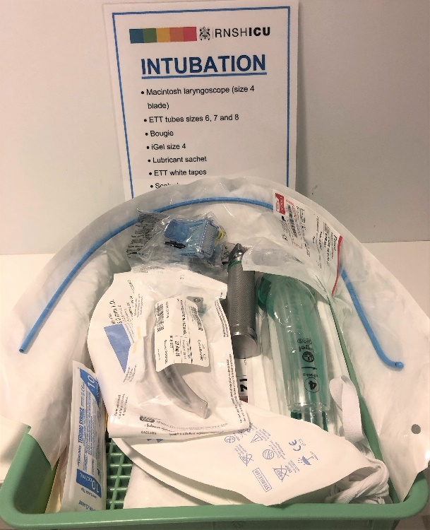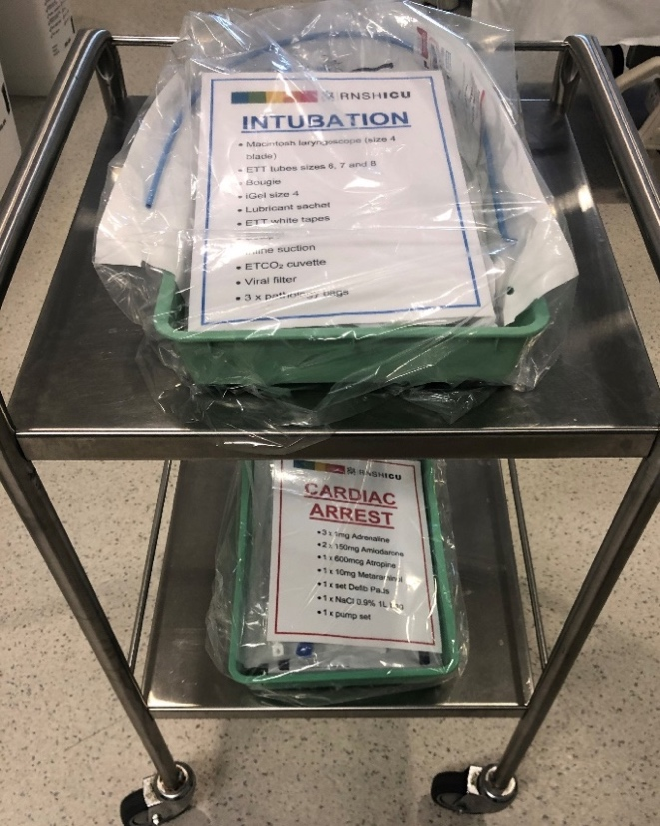

***Fig. 1 Covid 19 Intubation Tray and Trolley***

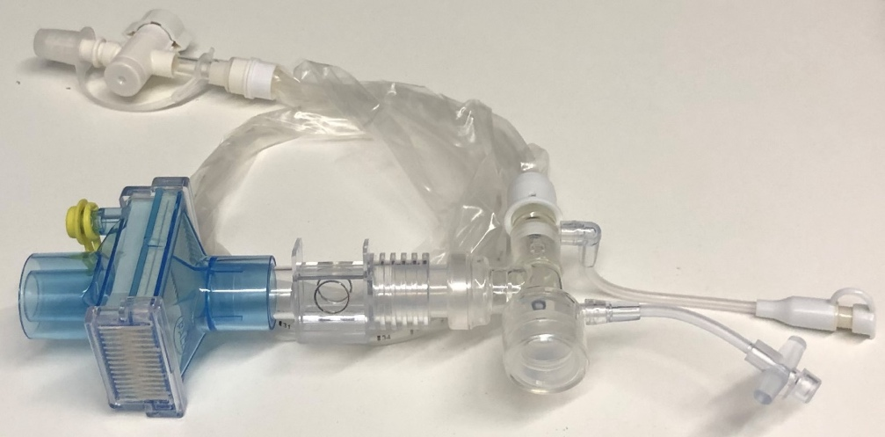

***Fig 2. Circuit assembly***

**2.4.2 Equipment to be immediately available outside the room for emergency use during intubation**

* Covid-19 Cardiac arrest tray, which contains:
  + Adrenaline 1mg x 3
  + Amiodarione 300mg
  + Atropine 600mcg
  + Metaraminol 10mg vial
  + Defibrillator pads
  + Pump set
  + 1 litre 0.9% saline
* Cardiac arrest trolley
* Airway trolley (contains other equipment which may be asked for in an emergency, e.g. different sized laryngoscope blades, endotracheal tubes, i-gels, facemasks, Melker cricothyroidotomy kit, airway exchange catheters etc.
* Ambu bronchoscope on drip stand with green (medium) bronchoscope in packet

**3.0 Intubation5**

* Before entering the room, the intubating team should check all equipment and drugs against the ‘BEFORE ENTERING THE ROOM’ section of the Covid-19 Emergency Intubation Checklist
* On entering room team should get into position
* Facemask should be attached to circuit assembly and ETCO2 zeroed (NB this takes up to 3 minutes)
* Guedel airway should be taken from the kidney dish in the room and placed on the silver intubation trolley
* High flow oxygen (via Hudson mask, non-rebreather mask or high flow nasal cannulae) should be removed and facemask, circuit assembly and Ambu/green resuscitator bag applied to patient, connected to 15L.min-1 oxygen
* Team should complete the ‘FINAL CHECK IN ROOM’ section of the Covid 19 Emergency Intubation checklist as a challenge-response ‘time-out’
* Patient should be repositioned from the pre-oxygenation position (45° head up) to the intubating position (‘sniffing’ or ‘ear-to-sternal notch’ position)
* Rapid sequence induction should be performed to minimise mask ventilation
* An adequate dose of muscle relaxant is essential to avoid coughing and facilitate intubation:
  + Rocuronium 1.5mg.kg-1 ideal body weight
  + Suxamethonium 1.5mg.kg-1 total body weight
* Apnoeic oxygenation (via high flow nasal prongs or standard nasal prongs at 15L.min-1) should NOT routinely be used during intubation attempts due to proximity of intubator to patient’s airway
* Two-handed mask ventilation should be performed to minimise gas leak
* Airway assistant should gently squeeze bag during mask ventilation
* Videolaryngoscope should be used first look, using screen, with operator standing upright
* If a bougie or stylet is used, care must be taken not to cause contamination when removing it from the patient’s airway. It should be laid down carefully on a ‘bluey’ on the patient’s bed, and wrapped and disposed of carefully after intubation.
* Care should be taken to place tube to correct depth first time, to minimise disconnections and cuff deflations
* Once tube placed, cuff should be inflated before positive pressure ventilation is attempted
* Remove MASK ONLY and attach circuit assembly and Ambu/green resuscitator bag to endotracheal tube
* Check all connections
* Inflate bag to ensure chest rise and ETCO2
* Remove Ambu Bag/green resuscitator bag ONLY and connect to green catheter mount on ventilator tubing. Check all connections
* Airway assistant to secure tube with white tube tie while intubator holds tube
* In case of difficult/failed intubation:
  + Call for anaesthetist (if not already present)
  + Plan B: i-gel supraglottic airway gentle ventilation to minimise air leak, consider fibre-optic conversion to ETT
    - Size 3 i-gel takes 6.0 tube
    - Size 4 i-gel takes 7.0 tube
    - Size 5 igel takes 8.0 tube
  + Plan C: Two-handed facemask ventilation with +/- Guedel/nasopharyngeal airway, airway assistant squeezing bag
  + Plan D: Scalpel-bougie-tube technique (size 6.0 ETT)

**4.0 Post intubation**

* The C-Mac blade should be bagged and sealed for sterilisation by CSSD
* The Macintosh laryngoscope should remain in the patient room for use in emergencies (unless soiled)
* The procedure for removal of equipment for sterilisation is as follows:
  + Equipment (e.g. C-Mac blade) placed in specimen bag in room, bag then sealed
  + Bag taken into ante-room and placed on ‘dirty’ bench
  + PPE removed EXCEPT facemask, hand hygiene, new gloves donned
  + Outside of specimen bag cleaned with S7 wipes
  + Bag placed on ‘clean’ bench
  + Gloves and mask removed, hand hygiene
  + Bag taken outside and placed into second specimen bag held open by second staff member (wearing gloves and surgical mask)
  + Bag taken to specimen reception in CSSD (who should be contacted in advance to warn that equipment coming).
* Any unused disposable equipment (e.g. bougie, endotracheal tubes, i-gel supraglottic airway, scalpel) should be kept in the room for future use in the same patient, and eventually discarded.
* The blue ‘transport’ filter should be removed once the patient’s tube has been secured and mechanical ventilation has been established, as these filters can become wet over a short period. Follow procedure below:
* Planned disconnections of the ventilator circuit:
  + should be kept to a minimum
  + should be performed using the ‘manual disconnect’ feature of the ventilator or by placing ventilator on standby
  + require the same level of PPE as intubation
  + If patient is very PEEP dependent, consider clamping tube prior to disconnection

**5.0 Extubation**

Patients should be ready for extubation onto facemask, nasal prong or nasal high flow oxygen, because non-invasive ventilation should be avoided where possible.

* Two staff members should perform extubation
* The same precautions should be taken for extubation as for intubation (full PPE including face shield)
* Increase FIO2 to 100%
* Prepare Hudson mask and connect to oxygen
* Suction mouth and via endotracheal tube
* Remove tapes but hold tube in place
* Place ventilator on standby and then disconnect ventilator tubing from catheter mount (leaving in-line suction, end tidal CO2 and catheter mount attached to tube to avoid spray)
* Do NOT ask the patient to cough on extubation
* Deflate cuff and remove tube at end expiration
* Quickly place Hudson mask over patient’s mouth to minimise spray
* Secure mask around patient’s head
* Dispose of endotracheal tube and circuit assembly carefully.

**6.0 Questions?**

Please contact one of the Clinical Nurse Educators or Dr Jon Gatward, Airway Lead, RNSH ICU

**7.0 References**

1. World Health Organistion. Infection prevention and control during health care when novel coronavirus (nCoV) infection is suspected. Interim guidance: 25 January 2020.

2. Anesthesia Patient Safety Foundation. Perioperative Considerations for the 2019 Novel Coronavirus (COVID-19). February 12, 2020.

3. Kotoda M, Hishiyama S, Mitsui K, et al. Assessment of the potential for pathogen dispersal during high-flow nasal therapy. *J Hosp Infect* 2019 doi: 10.1016/j.jhin.2019.11.010 [published Online First: 2019/11/24]

4. Hui DS, Chow BK, Lo T, et al. Exhaled air dispersion during high-flow nasal cannula therapy versus CPAP via different masks. *Eur Respir J* 2019;53(4) doi: 10.1183/13993003.02339-2018 [published Online First: 2019/02/02]

5. Zuo MZ, Huang YG, Ma WH, et al. Expert Recommendations for Tracheal Intubation in Critically ill Patients with Noval Coronavirus Disease 2019. *Chin Med Sci J* 2020 doi: 10.24920/003724 [published Online First: 2020/02/28]

**8.0 Appendix - RNSH ICU Covid 19 Intubation Checklist**

