http://arthritisnsw.org.au/arthritis/information-sheets/multicultural-information/

Simply click the links below to view the information sheet as a PDF.
Arabic:
What is arthritis? ( )
Dealing with pain ( )
Healthy eating and physical activity ( )
Medicines and arthritis ( )
Working with your healthcare team ( )
Methotrexate ()
NSAIDs ()
Paracetamol ()
Complementary therapies ()
Osteoarthritis ()
Rheumatoid arthritis ()
Fish oils ()
Glucosamine and chondroitin ()
Chinese:
What is arthritis? ( )
Dealing with pain ( )
Healthy eating and physical activity ( )
Medicines and arthritis ( )
Working with your healthcare team ( )
Methotrexate ()
NSAIDs ()
Paracetamol ()
Complementary therapies ()
Osteoarthritis ()
Rheumatoid arthritis ()
Fish oils ()
Glucosamine and chondroitin ()
Croatian:
What is arthritis? (Što je artritis?)
Dealing with pain (Kako živjeti s bolovima)
Healthy eating and physical activity (Zdrava ishrana i fizička aktivnost)
Medicines and arthritis (Lijekovi i artritis)
Working with your healthcare team (Surađujte sa svojim timom zdravstvenih djelatnika)
Complementary therapies (Dopunske terapije)
Greek:
What is arthritis? ( )
Dealing with pain ( )
Healthy eating and physical activity ( )
Medicines and arthritis ( )
Working with your healthcare team ( )
Methotrexate ()
NSAIDs ()
Gout ()
Paracetamol ()
Complementary therapies ()
Osteoarthritis ()
Rheumatoid arthritis ()
Fish oils ()
Glucosamine and chondroitin ()
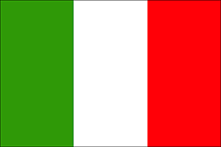Italian:
Complementary Therapies (Terapie complementari)
Fish Oils (Oli di pesce)
Glucosamine and chondroitin (Glucosamina e condroitina)
Non-Steroidal Anti-Inflammatory Drugs (NSAIDs)(Farmaci antinfiammatori non steroidei) (FANS)
Osteoarthritis (Osteoartrite)
Paracetamol(Paracetamolo)
Rheumatoid arthritis (Artrite reumatoide)
Dealing with pain (Come far fronte al dolore)
Healthy eating and physical activity (Mangiare sano e attività fisica)
Medicines and arthritis (I farmaci e l’artrite)
What is arthritis? (Cos’è l’artrite?)
Working with your healthcare team (Collaborate con il team di operatori sanitari)
Korean:
What is arthritis? ( )
Dealing with pain (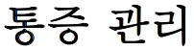 )
Healthy eating and physical activity ( )
Medicines and arthritis ( )
Working with your healthcare team ( )
Complementary therapies ( 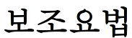)
Macedonian:
What is arthritis? (Што е артритис?)
Dealing with pain (Справување со болки)
Healthy eating and physical activity (Здрава исхрана и физички активности)
Medicines and arthritis (Лекови и артритис)
Working with your healthcare team (Соработка со вашиот здравствен тим)
Complementary therapies (Комплементарни терапии)
Persian:
What is arthritis? ( 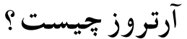)
Dealing with pain ( 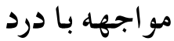)
Healthy eating and physical activity ( )
Medicines and arthritis (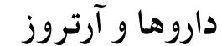 )
Working with your healthcare team ( 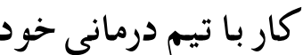)
Complementary therapies (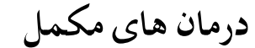 )
Spanish:
What is arthritis? (¿Qué es la artritis?)
Dealing with pain (Sobrellevar el dolor)
Healthy eating and physical activity (La alimentación sana y la actividad física)
Medicines and arthritis (La alimentación sana y la actividad física)
Working with your healthcare team (Recurra al equipo de atención médica)
Complementary therapies (Terapias complementarias)
Vietnamese:
What is arthritis? ( )
Dealing with pain ( )
Healthy eating and physical activity ( )
Medicines and arthritis ( )
Working with your healthcare team ( )
Methotrexate
NSAIDs ()
Paracetamol ()
Complementary therapies ()
Osteoarthritis ()
Rheumatoid arthritis ()
Fish oils ()
Glucosamine and chondroitin ()
Please contact Arthritis & Osteoporosis NSW, on 1800 011 041, if you would like any further information.
Published Mar 2015. © State of NSW (Agency for Clinical Innovation)

